Architectural design

# Overview

Architectural design is of crucial importance in software engineering because it will have to take account of functional and non-functional requirements, to meet the stakeholders needs and requests, and to help not to focus only on standalone elements losing the so called big picture of the system, always adhering to general principles of good quality. An important aspect is in fact to find a good trade-off between the high-level description near to the analysis and the low-level one near to the implementation.

Coming up with good quality design and architecture is mostly a matter of experience and in our field, is also known the importance of the reusability of other’s people work. So, we tried to build our system with various kind of this patterns and known architectural styles.

# Component view

High level components

The picture below will give a representation of the high-level structure of the system and a general view of its main components.

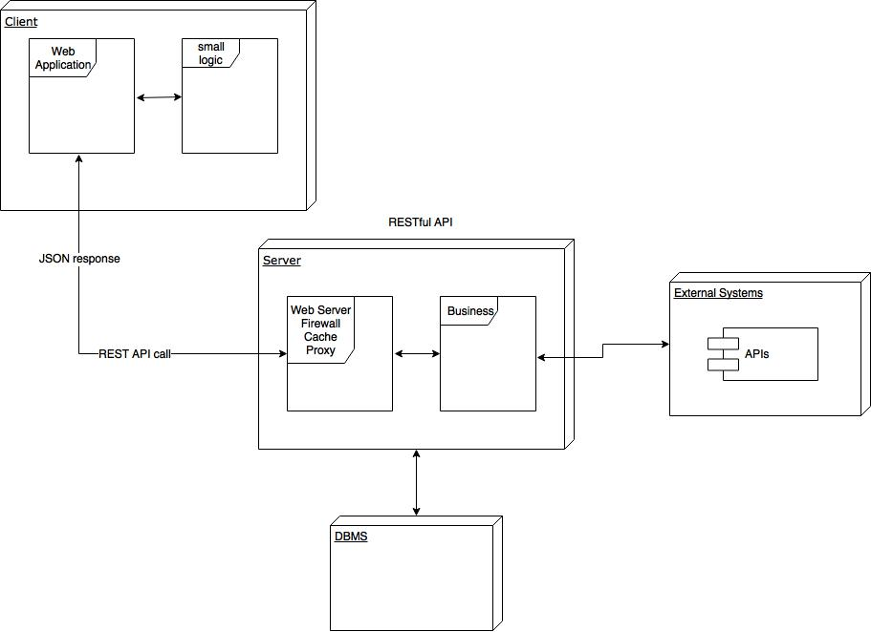

The client layer will send requests to the server through REST API call. More precisely these requests will be send to the first component of the application layer, the web server. Here the request has to pass through the firewall, then the proxy will direction it to the distributed collection of servers that represents the business layer. The proxy is also in charge to do the opposite communication, when the pieces of information will flow from the business servers, they will have to be directed to the opportune client and the reverse proxy will send to the right client JSON responses.

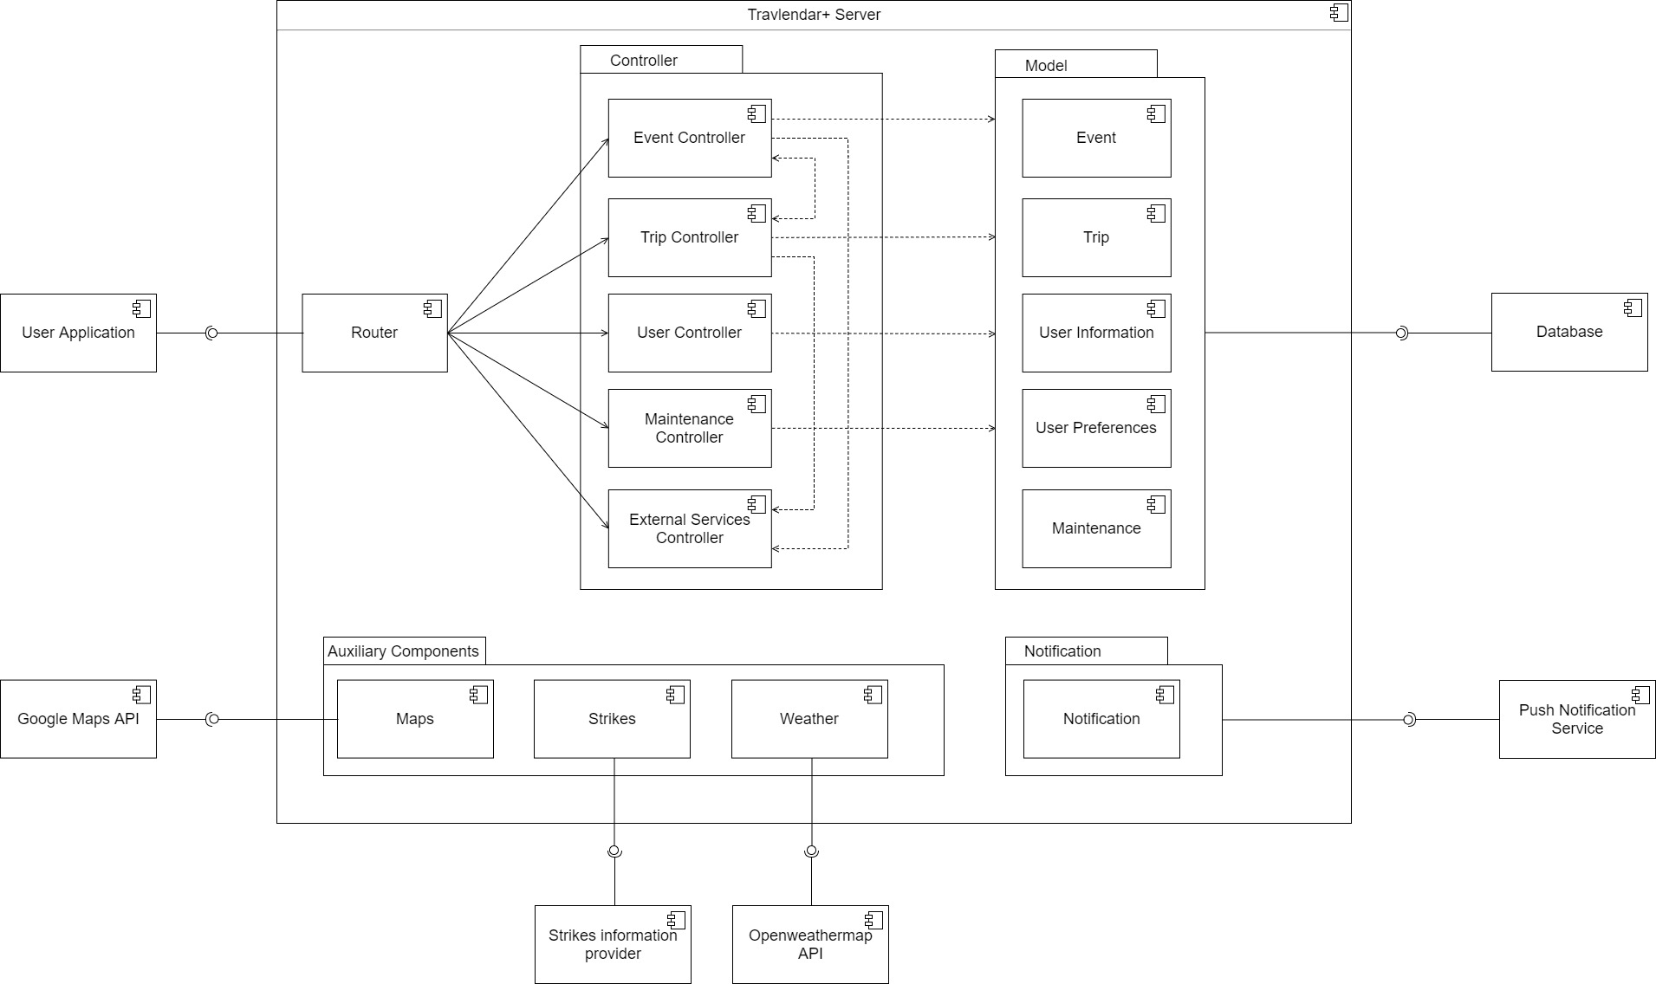

The main components are divided in:

* Controller set of components
  + Event Controller: in charge of the management of events, it will provide functions for adding, modify and delete events and will contain all the logic to do this properly.
  + Trip Controller: in charge of the management of the trips. It will contain all the necessary logic to avoid overlapping of them and to advise the best option for the user.
  + User Controller: in charge of the management of the user’s info and preferences
  + Maintenance Controller: in charge of the management of the maintenance of the system.
  + External Services Controller: in charge of the management of the external services connected to the system.
* Model set of Components are divided in:
  + Event: will contain all the information concerning the events
  + Trip: will contain all the information concerning the trips
  + User Information: will contain all the information concerning the user’s general info
  + User Preferences: will contain all the information concerning the user’s preferences
  + Maintenance: will contain all the information concerning the maintenance of the system

This layer is strictly connected to the database with which it can exchange data.

* Auxiliary Components and Notifications components are:
  + Maps: will be connected to the Google Maps API
  + Strikes: will be connected to a multitude of APIs from which it will collect all the necessary info
  + Weather: will be connected to Open Weather Map API to collect info about weather conditions

It is also present a Router to route request to the appropriate controller.

# Deployment view

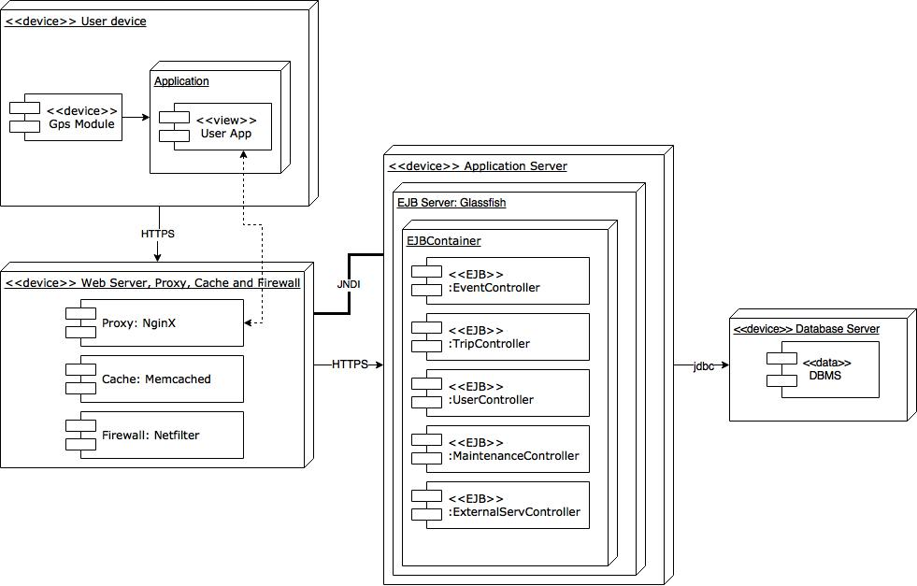

Since our system is subject to several loads concerning data storage and other services we taught that the best deployment solution may be cloud computing, considering also the recent diffusion and opportunity to have access to powerful services with limited costs.

To be as general as possible and avoid further implementation constraints we prefer to rely on the

IaaS (Infrastructure as a Service) level. It’s specifically a virtualized hardware, in other words an elaboration infrastructure. It includes offers like virtual storage space on servers, network connections, bandwidth and load balancing. Physically, the collection of hardware resources is extracted from several distributed servers and networks usually in different data centres, which maintenance is responsibility of the cloud provider.

The client, on the other hand, has access to virtualized components to build his IT platforms.

The main advantages are of this approach are:

* Scalability: thanks to IaaS upwards and downwards scalability is performed, delays are reduced and waste of resources is prevented.
* Costs: base hardware is configured and managed by the cloud provider, therefore no acquisition, installation and maintenance cost are necessary; the cost of the cloud service is almost proportionally to the amount of resource consumed, there are various contracts that allows to design a kind of customized service.
* Security: in IaaS configuration, physical security is ensured since it is typically a critical aspect for the provider. In-house security, on the other hand, is not usually an individual’s or an organization’s main business and, therefore, may not be as good as that offered by the IaaS cloud provider.
* Availability, Redundancy and Fault Tolerance: deploying different components on different machines allows the system not to totally go down if one of his components crashes. There’s also no need to manage backups because lots of IaaS cloud providers offer automatic backup procedures.

On the other hand, some constraints must be respected:

* for the scaling mechanism, we have to design stateless components
* we have also do upgrade the developed software
* we have to take care of the maintenance of tools, database systems and the underlying infrastructure

# Runtime view

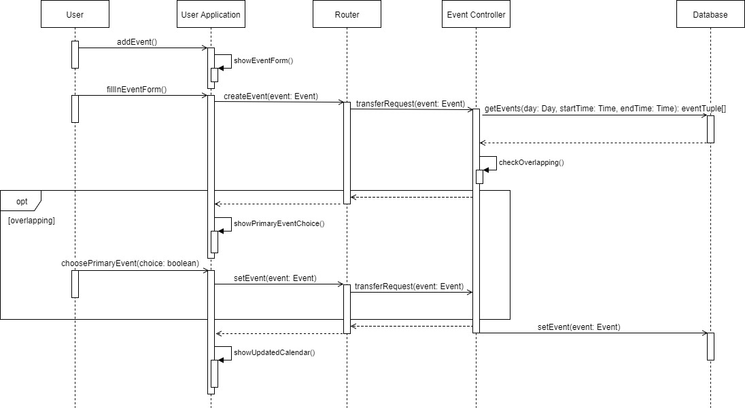

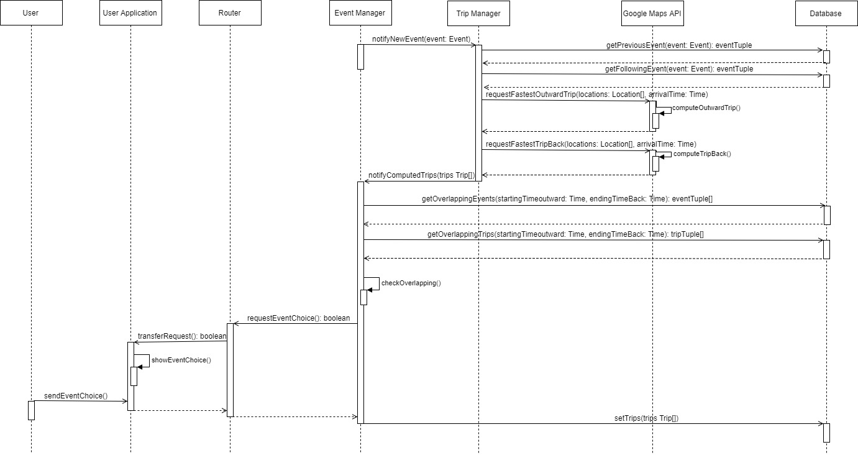

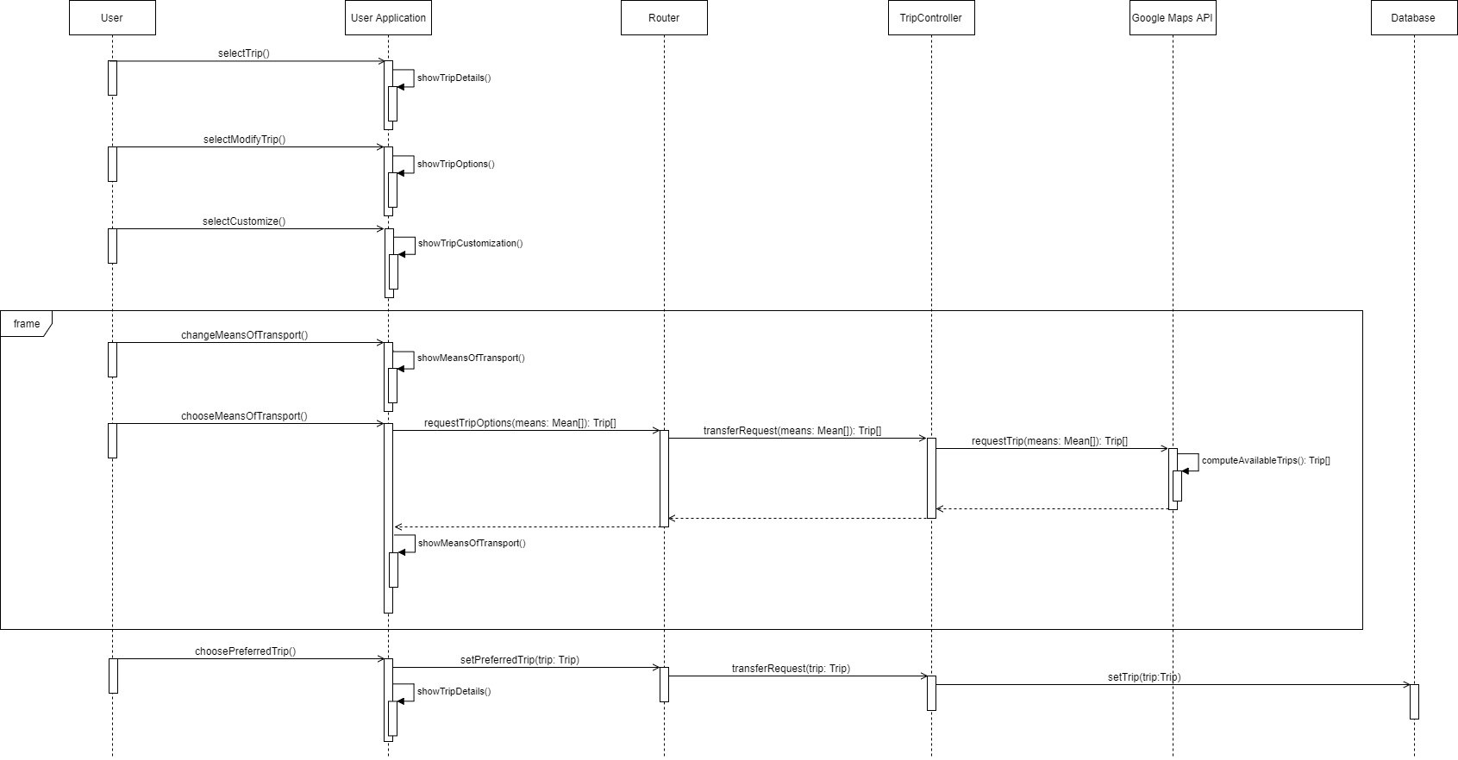

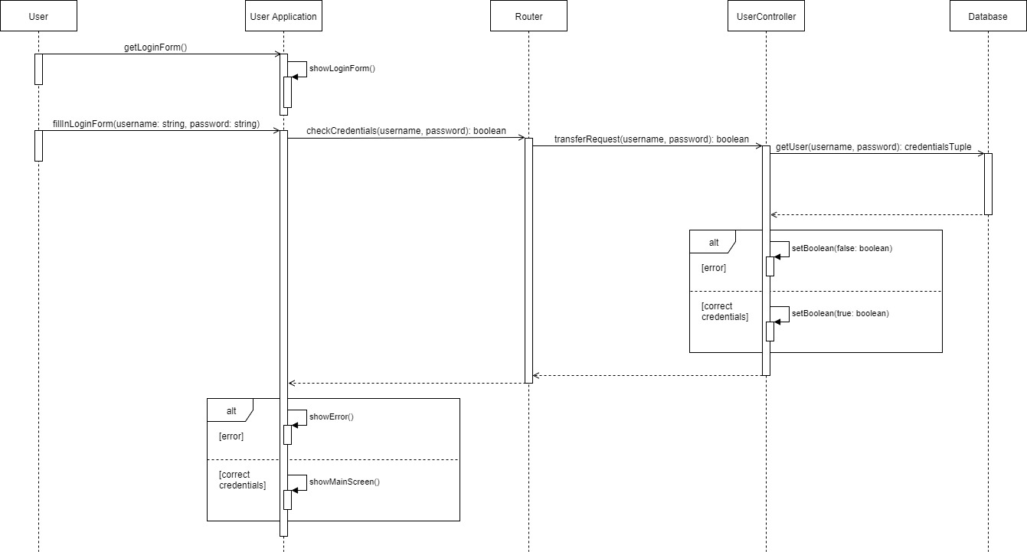

# Component Interfaces

* User Application Interface: responsible for communication between the user application and the application server. The communication will be provided with the HTTPS protocol mostly for security reasons.
* Open Weather Map: it gives information about the weather and then the system task will be to compute trips looking also to these pieces of information. For example, if it will be raining it will not suggest a bike trip.
* Strikes Information Provider: it gives to our system information about all the possible strikes concerning public means and then it will be the system that will use this information to compute the best travel option for the user.
* Google Maps API: it’s used for:
  + calculate all the trip times associated to each event, obviously for all types of means (car, bike, public means etc.)
  + provides information about the traffic to optimize the computation of trip times
  + provides the static map that the user will see
* DBMS API: through this the system can retrieve and write data from and to the database. It’s strictly connected to the model through JDBC connector.

# Selected architectural styles

Architectural style: Client-Server

It’s the best known and most used architectural style for distributed applications.

It’s present a well-defined distinction between client and server, they play different roles and also, they are both accessible with a precise interface.

Travlendar+ is a mobile application and will have multiple mobile users, but still the computation portion needs to be located in some point where the global view of the system can be seen.

The system must guarantee scalability so, resources in the form of network segments, computers and servers must be added to the network without major interruptions of it.

Said that, we agreed that the best solution for our needs could be the Client-Server style.

* Server is invoked to provide one or a set of services, in our case, for instance, the computation of the best mobility option for the user according to all of his characteristics.
* Clients uses the provided services and initiate the communication through messages or remote invocations. They interact directly with end-users using any user interface such as graphical user interface. These are the user logged in to the application.

In the end, we will talk about web clients, which means that in our scenario, they will ask the server to provide services for them and they will not store data locally. Furthermore, the architecture is OS independent, it relies on a central server that will avoid consistency issues between different devices of the same client.

Three-tier architecture

The Client-Server model does not impose any constraint neither about how logical layers (presentation, application/business logic, data) have to be distributed among the deployment units nor about the physical tiers have to be designed.

We taught that the best decision for us could have been the three-tier architecture where each tier is elastically scaled independently.

That’s composed of:

* First tier: Presentation layer located into the mobile application. Handles the interaction with the user. It’s also in charge of some simple validations of the data and the interaction with external systems. Here will be handled all the visualization portion of the system based on the data received from the application layer.
* Second tier: web/business layer. Process and executes both new requests of the clients and possible variations on older and not yet completed requests. It will collect information from the users and store them into the databases, but also it will provide to them answers for their requests.

More precisely, this layer’s tasks are to filter, cache and forwarding the requests between clients and the application server and vice versa.

It’s also responsible (web layer) of the visualization to the user.

* Third tier: Data layer. Dedicated to the storage of information in persistent memory. Data is stored at different locations (replicas) to improve response time and to avoid data loss in case of failures while consistency of replicas is ensured at all times.

This architecture permits us to achieve one of the design principles, that says to decouple where possible, in fact we have a solid distinction between logic and data, and also between logic and presentation.

Basic architectural patterns:

Stateless components

The state is handled external of application components to ease their scaling-out and to make the application more tolerant to component failures.

In this system cloud resources can display low availability and also component instances can be added and removed regularly when the demand changes.

So, components will be implemented in a way that the do not have any internal state. Instead it will be provided to the component with each request form external persistent storage.

User interface component

An interactive synchronous access to the applications is provided to users, instead the interactions in the application are asynchronous if possible, to ensure loose coupling (Principle 3 of the design principles).

In other words, the user interface component is like a bridge between the synchronous access of the user and the asynchronous communication with other components. Like for stateless components also these ones are obtained from external storage.

The number of components are scaled based on the number of user requests through the elastic load balancer pattern.

Elastic load balancer

The number of required components instances is determined by the quantity of synchronous request coming from the users.

Processing component

Processing functionalities are divided into separate blocks and assigned to independent processing components each one implemented in a stateless way as explained above.

Elastic queue

Queues are used to distribute asynchronous requests to multiple application component instances. From the number of messages queued will be decided the number of component instances handling that requests.

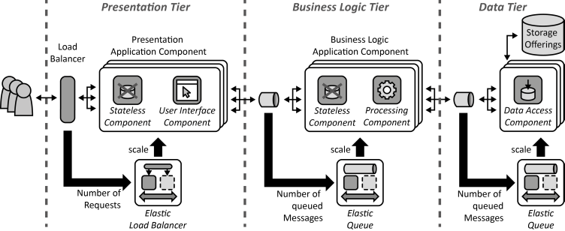

# Architectural pattern

Model View Controller

The model-view-controller (MVC) design pattern specifies that an application consist of a data model, presentation information, and control information. The pattern requires that each of these be separated into different objects.

* The model contains only the pure application data, it contains no logic describing how to present the data to a user, but only data and operations associated to that.
* The view presents the model's data to the user. The view knows how to access the model's data, but it does not know what this data means or what the user can do to manipulate it.
* The controller exists between the view and the model. It listens to events triggered by the view (so by the user) and executes the appropriate response to these events, usually calling a method on the model and passing the results both to the view and the model.

A key aspect is to separate data and its presentation. This not only makes the structure of an application simpler, it also enables code reuse and ensures loose coupling.

It also guarantees the divide and conquer principle allowing parallel development by separated teams in charge of different parts of the application.

An example of how can be represented the MVC pattern is shown in the figure below.

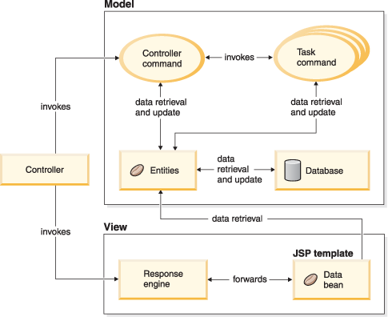

Commercial architectural system

To support the development and the execution on enterprise application with a lot of users and lots of requirements we suggest the usage of Java Enterprise Edition (JEE).

That’s a multitier architectural model composed by the client-tier running on the client machine (as we said before in this paragraph, the clients involved in Travlendar+ will be web clients), the business-tier running on the Java EE Server and the enterprise information system (EIS) consisting of databases or other external applications.

This approach will help us also to satisfy non-functional requirements like reliability, performance, security, scalability, availability, extensibility and interoperability.

The client tier will welcome web clients composed of dynamic web pages, which are generated by web components running in the web tier and a web browser, which renders the pages received

from the business layer.

The application tier will be divided into:

* The web layer: in charge of the presentation of the data to the user, it will collect the responses of a client request coming from different servers in the distributed business tier and will send them to the correct user written more likely in JSP or Java Server Faces.

It will also be in charge of firewall, cache, proxy and reverse proxy functions.

* The business layer: managing the computing and the execution of the business logic using components called Enterprise Java Beans (EJB) and also interacting with the database through Java Persistence API (JPA).

In the end, the Enterprise Information System (EIS) is devoted to the data management and will operate like a DBMS.

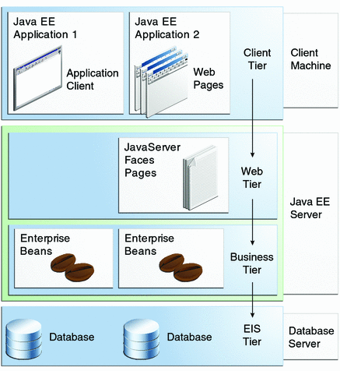

# Other design decisions

Push Notifications

To send notifications to the Travlendar+ users we choose the Push Notification Technology, obviously supported by iOS and Android.

The APIs we are going to use are:

* Apple Push Notification Service for iOS
* Google Cloud Messaging for Android